1) Which vessel is recognized by a transverse, belt-like course around the waist?
A) Dai Mai +++++
B) Chong Mai
C) Yang Qiao Mai
D) Yin Wei Mai
Feedback: Dai Mai is the Girdling Vessel and is distinguished by its transverse belt-like course around the waist. Why are the other options incorrect? Chong Mai — Chong Mai has a deep central lower-abdominal and trunk distribution. Yang Qiao Mai — Yang Qiao Mai rises from the lateral heel toward the eye. Yin Wei Mai — Yin Wei Mai ascends medially toward the throat.
2) Which vessel has a deep central relationship with the lower abdomen and trunk?
A) Dai Mai
B) Chong Mai +++++
C) Yang Wei Mai
D) Governing Vessel Luo
Feedback: Chong Mai, the Penetrating Vessel, is recognized by its deep central lower-abdominal and trunk distribution. Why are the other options incorrect? Dai Mai — Dai Mai runs transversely around the waist. Yang Wei Mai — Yang Wei Mai links lateral Yang regions. Governing Vessel Luo — The Governing Vessel Luo is a special Luo pathway, not the Chong Mai.
3) Which vessel rises from the lateral heel through the lateral body toward the eye?
A) Yang Qiao Mai +++++
B) Yin Wei Mai
C) Dai Mai
D) Chong Mai
Feedback: Yang Qiao Mai, the Yang Motility Vessel, rises from the lateral heel and continues toward the eye. Why are the other options incorrect? Yin Wei Mai — Yin Wei Mai follows a medial lower-limb and trunk route toward the throat. Dai Mai — Dai Mai girdles the waist. Chong Mai — Chong Mai has a deep central distribution.
4) Which vessel links Yang regions along the lateral body, shoulder and head?
A) Yang Wei Mai +++++
B) Yin Wei Mai
C) Chong Mai
D) Dai Mai
Feedback: Yang Wei Mai, the Yang Linking Vessel, connects lateral Yang regions of the body, shoulder and head. Why are the other options incorrect? Yin Wei Mai — Yin Wei Mai links Yin regions along a medial pathway toward the throat. Chong Mai — Chong Mai is primarily deep and central. Dai Mai — Dai Mai is transverse around the waist.
5) Which vessel ascends along the medial lower limb through the abdomen and chest toward the throat?
A) Yin Wei Mai +++++
B) Yang Wei Mai
C) Yang Qiao Mai
D) Dai Mai
Feedback: Yin Wei Mai, the Yin Linking Vessel, follows a medial route through the trunk toward the throat. Why are the other options incorrect? Yang Wei Mai — Yang Wei Mai follows lateral Yang regions. Yang Qiao Mai — Yang Qiao Mai begins at the lateral heel and continues toward the eye. Dai Mai — Dai Mai encircles the waist transversely.
6) What is the best first step when identifying an Extraordinary Vessel image?
A) Identify its overall geometry, then confirm with landmarks. +++++
B) Select the vessel by color alone.
C) Assume every midline route is Dai Mai.
D) Look only for a numbered acupuncture point sequence.
Feedback: Overall geometry narrows the vessel, and specific anatomical landmarks then confirm the identification. Why are the other options incorrect? Select the vessel by color alone. — Color varies among diagrams and cannot establish identity. Assume every midline route is Dai Mai. — Dai Mai is transverse rather than simply any midline route. Look only for a numbered acupuncture point sequence. — Extraordinary Vessel recognition is not based only on an ordinary Primary Channel point sequence.
7) A diagram circles the waist horizontally. Which alternative is least consistent with that geometry?
A) Dai Mai
B) A transverse girdling pathway
C) Yang Qiao Mai +++++
D) The Girdling Vessel
Feedback: Yang Qiao Mai is least consistent because it ascends longitudinally from the lateral heel toward the eye. Why are the other options incorrect? Dai Mai — Dai Mai is the correct name for the transverse route. A transverse girdling pathway — A transverse girdling pathway describes Dai Mai’s geometry. The Girdling Vessel — The Girdling Vessel is the English name of Dai Mai.
8) Why should the Governing Vessel Luo not be classified as an Extraordinary Vessel answer in this picture bank?
A) It is presented here as a special Luo pathway with a posterior midline/back distribution. +++++
B) It has no pathway.
C) It is another name for Dai Mai.
D) It is one of the Twelve Primary Channels.
Feedback: Although the Governing Vessel is an Extraordinary Vessel, the specific image here identifies its Luo-Connecting pathway and is therefore classified as Special Luo for this exercise. Why are the other options incorrect? It has no pathway. — The Governing Vessel Luo does have a described pathway. It is another name for Dai Mai. — Dai Mai is a different Extraordinary Vessel with a transverse waist course. It is one of the Twelve Primary Channels. — The Governing Vessel is not one of the Twelve Primary Channels.
9) What is the channel shown in the image?
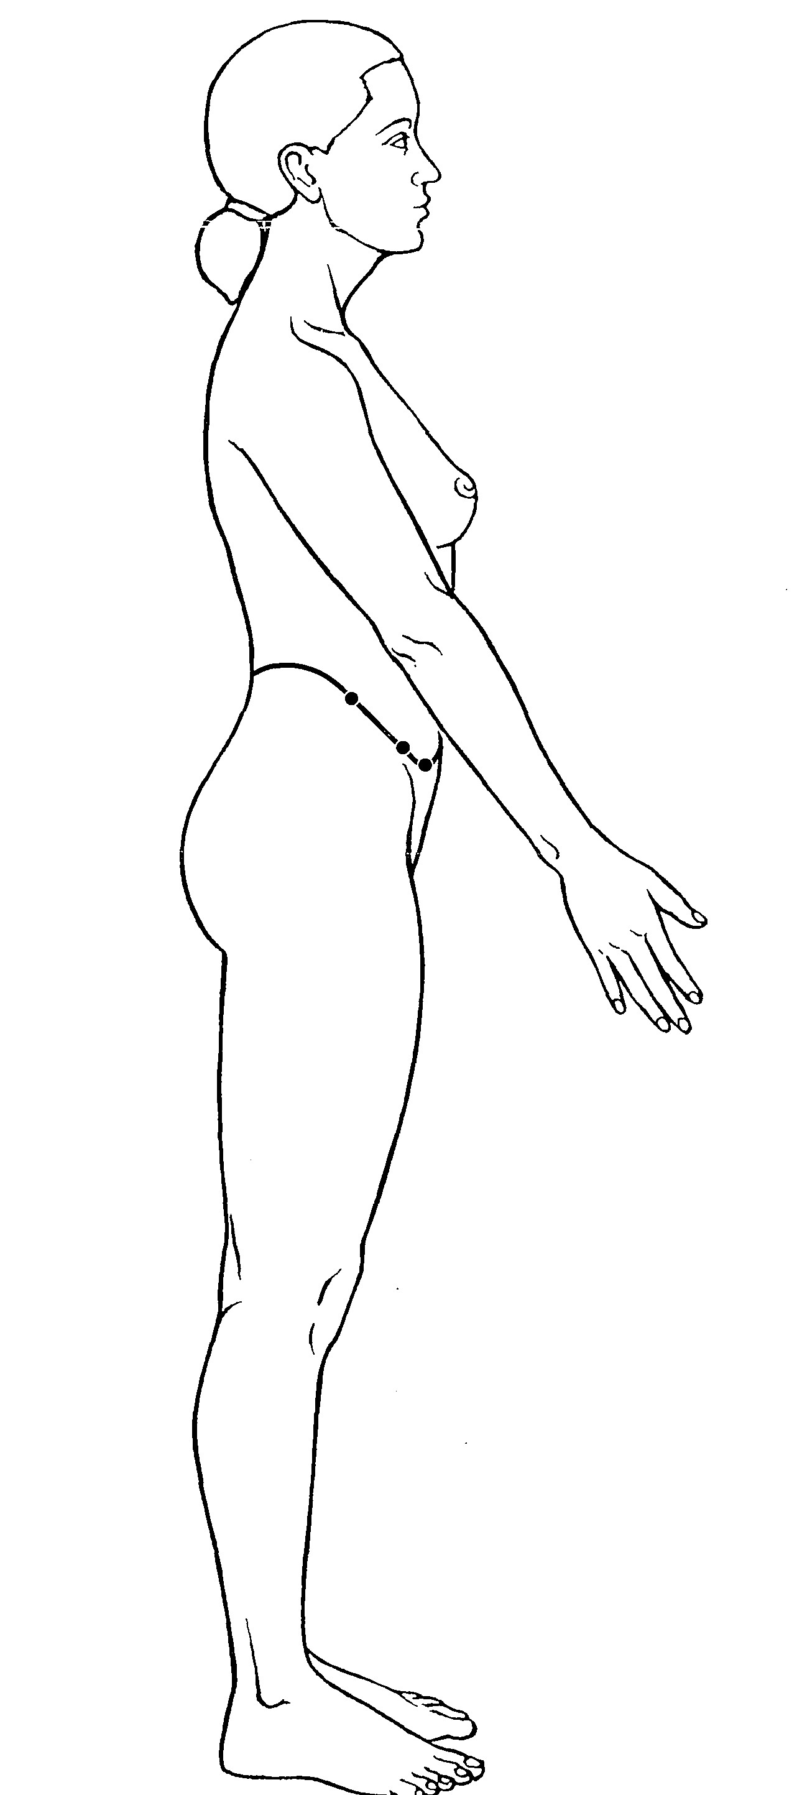
A) Girdling Vessel +++++
B) Penetrating Vessel
C) Yang Linking Vessel
D) Governing Vessel Luo
Feedback: The Girdling Vessel is identified by its unique transverse course around the waist like a belt, passing through the lateral waist region associated with GB-26, GB-27 and GB-28 rather than following a longitudinal limb-to-trunk pathway. Why are the other options incorrect? Penetrating Vessel — The Penetrating Vessel has a central ascending and abdominal distribution. Yang Linking Vessel — The Yang Linking Vessel links Yang regions and follows a different longitudinal course. Governing Vessel Luo — The Governing Vessel Luo is associated with the posterior midline and back.
10) What is the channel shown in the image?
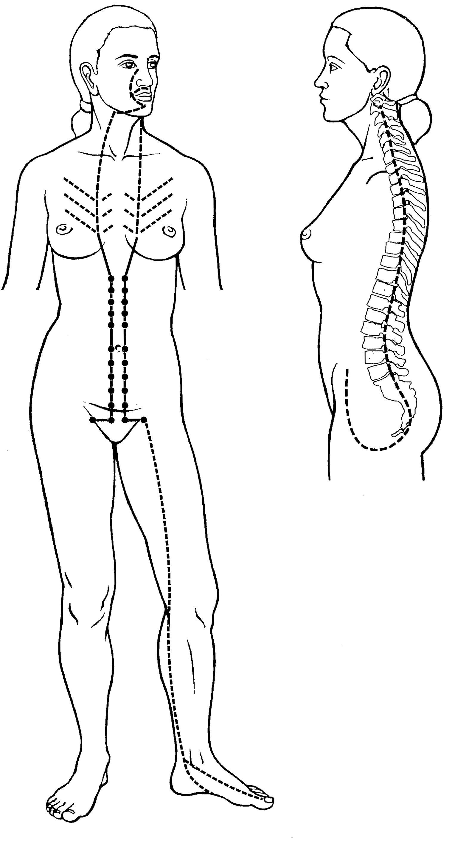
A) Penetrating Vessel +++++
B) Girdling Vessel
C) Yang Motility Vessel
D) Yin Linking Vessel
Feedback: The Penetrating Vessel arises in the lower abdomen and uterine region, emerges through the perineal area and sends an ascending branch through the abdomen and chest, with an associated posterior branch along the spine. This central distribution identifies Chong Mai. Why are the other options incorrect? Girdling Vessel — The Girdling Vessel is recognized by its transverse belt-like course around the waist. Yang Motility Vessel — The Yang Motility Vessel ascends from the lateral heel toward the eye. Yin Linking Vessel — The Yin Linking Vessel connects Yin regions through a different medial route.

